# Intruder Detection System

## 1. Introduction

This project is a real‑time intruder detection system running on a local network. It uses an RTSP CCTV feed, performs deep‑learning‑based face recognition using InsightFace, detects unknown individuals with a time‑based confirmation system, sends Telegram alerts, and provides a dashboard for live monitoring and user management.

## 2. Key Technologies

- **InsightFace**: Deep learning face recognition (ArcFace embeddings).

- **OpenCV** (cv2): RTSP reading, frame decoding, face detection, rendering.

- **Flask**: Dashboard, routing, MJPEG live stream.

- **Threading** & **Locks**: Smooth non‑blocking frame sharing.

- **RTSP Stream**: Primary CCTV source.

- **Telegram Bot API**: Intruder alerts.

- **Local Storage:** User images + intruder captures.

## 3. System Architecture

The system consists of:

1. Detection Engine (main.py) – Reads RTSP frames, runs InsightFace recognition, handles intruder logic.

2. Dashboard Server (Flask) – Web UI for monitoring, managing users, retraining.

3. CameraStream Module– Threaded global camera reader.

4. Face Recognition Module (face_recog.py) – InsightFace embeddings for training + recognition.

5. Utils Module– Saving images, sending Telegram alerts.

6. Data Storage – User profiles & intruder snapshots.

## 4. InsightFace Face Recognition Pipeline

InsightFace replaces the older LBPH recognizer. The pipeline is:

1. Detect face (Haarcascade).

2. Align the face.

3. Extract 512‑D embeddings using InsightFace ArcFace model.

4. Compare embeddings using cosine similarity.

5. If similarity < threshold → classified as Unknown.

This makes recognition far more accurate, consistent across angles, and robust to lighting changes.

## 5. Use of OpenCV (cv2)

- cv2.VideoCapture: RTSP and webcam frame reading.

- cv2.CascadeClassifier: Haarcascade face detection.

- cv2.cvtColor, cv2.resize: Preprocessing for InsightFace.

- cv2.rectangle, cv2.putText: Annotating bounding boxes.

- cv2.imencode: Streaming frames to dashboard.

- cv2.imwrite: Storing user & intruder images.

## 6. Threading and Locks

- CameraStream continuously reads CCTV frames in a background thread.

- Locks ensure safe shared access to the current frame.

- Processed annotated frames are also stored using a lock.

This enables real‑time performance without blocking Flask or the detection loop.

## 7. Recognition Flow

1. Load all saved user images.

2. Extract embeddings using InsightFace.

3. For each RTSP frame:

- Detect and crop face.

- Generate embedding.

- Compare with stored embeddings.

- Determine identity.

4. Draw bounding boxes and labels.

5. Push processed frame to dashboard.

## 8. Intruder Detection Logic

- If the detected face is Unknown → start a timer.

- If unknown > N seconds (default 2s):

- Save snapshot.

- Send Telegram alert (cooldown enabled).

- If known face appears → timer resets.

This avoids false alarms from momentary recognition errors.

## 9. Dashboard Features

- Live video feed with bounding boxes.

- Add user using local device camera (not RTSP feed).

- View/delete users.

- Retrain InsightFace embeddings on demand.

- View intruder snapshots.

## 10. Adding Users (Device Camera Only)

Users are added using the laptop/PC webcam, not the RTSP stream. This ensures close, high‑quality face samples which greatly improves InsightFace accuracy.

## 11. Folder Structure

project/

main.py

camera_stream.py

face_recog.py

utils.py

config.json

data/

users/

intruders/

dashboard/

app.py

templates/

## 12. End‑to‑End Workflow

RTSP Camera → CameraStream → Detection Engine → InsightFace Recognition → Intruder Logic → Processed Frame → Dashboard.

Dashboard → Add/Delete Users → Retrain → Updated Embeddings.

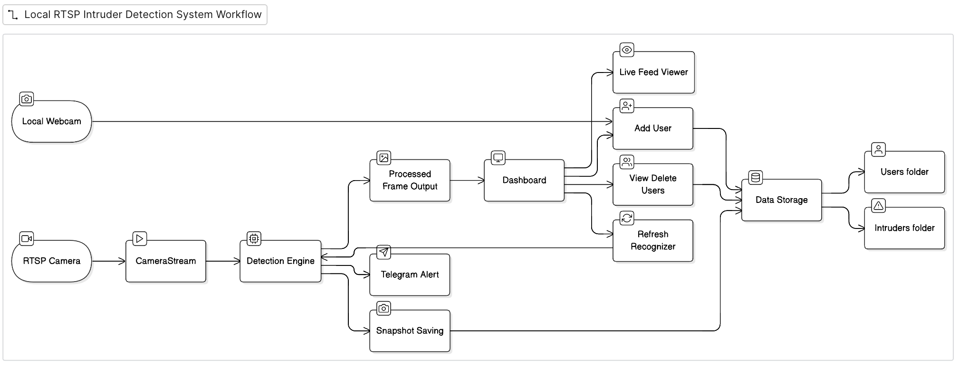

Live Demo

